Final

Problem 1
We can think of this problem as a Knapsack. Since we have the option of hiring 10 more programmers to halve the development time of each system $R_{i}$ (at the cost of $10a$ each month), we need to consider two Knapsack problems and take the max profit of the two.

First Knapsack: Do not hire 10 more programmers
Setup:
- The knapsack has capacity $m$.
- The weight of each item $R_{i}$ is $m_{i}$.
- The value of each item $R_{i}$ is $p_{i}$.
We want to bring the most value into the knapsack by selecting which items to bring, while keeping the total weight in the knapsack below the capacity.
Define optimality equation $\text{OPT}(j,m)$ to be the maximum total value possible when considering items $\left\{1,2,…,j\right\}$ with the constraint that the knapsack can carry as much as $m$ months.
Now, there are two cases:
- OPT does not select item $j$
  - In this case OPT selects best of $\left\{1,2,…j-1\right\}$ with weight limit $m$.
- OPT does select item $j$
  - In this case OPT select best of $\left\{1,2,…,j-1\right\}$ with weight limit $m-m_{j}$.
Similar to the lecture slides, we can fill up a table.
The algorithm is correct by construction. The time complexity is pseudo polynomial $O\left(m×n\right)$. The space complexity is the same.
The total profit given by this knapsack is exactly the total value carried by the knapsack. Let’s call the total profit here $P_{\text{no-hire}}$.

Second Knapsack: Hire 10 more programmers
Setup:
- The knapsack has capacity $m$.
- The weight of each item $R_{i}$ is $m_{i}^{'}=\frac{m_{i}}{2}$.
- The value of each item $R_{i}$ is $p_{i}$.
We want to bring the most value into the knapsack by selecting which items to bring, while keeping the total weight in the knapsack below the capacity.
Define optimality equation $\text{OPT}(j,m)$ to be the maximum total value possible when considering items $\left\{1,2,…,j\right\}$ with the constraint that the knapsack can carry as much as $m$ months.
Now, there are two cases:
- OPT does not select item $j$
  - In this case OPT selects best of $\left\{1,2,…j-1\right\}$ with weight limit $m$.
- OPT does select item $j$
  - In this case OPT select best of $\left\{1,2,…,j-1\right\}$ with weight limit $m-m_{j}^{'}=m-\frac{m_{j}}{2}$.
Similar to the lecture slides, we can fill up a table.
The algorithm is correct by construction. The time complexity is pseudo polynomial $O\left(m×n\right)$. The space complexity is the same.
Let’s call the total value obtained by all items in the knapsack $V_{\text{hire}}$. Here, since hiring 10 programmers for $m$ months will incur a cost of $10m×a$ to the company, the profit that we can make with this knapsack is then $P_{\text{hire}}=V_{\text{hire}}-\left(10m×a\right)$

Combine two knapsacks
With the above two knapsacks, we simply take the maximum of the two profits we found above.
$$P_{\text{max}}=\max\left(P_{\text{hire}}, P_{\text{no-hire}}\right)$$
Since the two knapsacks are solved using the same time and space complexity, the total time and space complexity is still $O\left(m×n\right)$.
Final touch here. The algorithm above gives a total profit only. To find out how exactly each system is developed or not, we can record, for each $\text{OPT}\left(j,m\right)$ whether case 1 or case 2 was chosen. With the information recorded, we can trace back from the final $\text{OPT}\left(j,m\right)$ to the beginning to write out which $R$’s (systems) were chosen in our final answer.

Problem 2
Let’s simply the problem first. Since we have more than enough desktops and specialized computers and they won’t block one another, we should just consider the postprocessing time defined to be the sum of desktop time and specialized computer time.
Postprocessing time: $p_{i}\overset{Δ}{=}\left(q_{i}+t_{i}\right)$
We can make one important observation: since there is only a single supercomputer, no matter how we rearrange the jobs $J_{1}$, $J_{2}$, …, $J_{n}$, the time spent on the supercomputer is always $R_{\text{tot}}=r_{1}+r_{2}+…+r_{n}$.
The problem now, given the above observation, is to order the jobs $J_{1}, J_{2},…,J_{n}$ so that we minimize the time to postprocess all the jobs. We need to keep in mind that $p_{i}$ and $p_{j}$ can run in parallel since we have enough desktops and specialized computers.
The proposed method is a greedy based solution.

Proposed solution: Greedy
The way to solve the problem is to use the greedy strategy on postprocessing time: schedule $J_{i}$ before $J_{q}$ if $p_{i}≤p_{q}$.
We can prove this using the strategy similar to the slides: swapping argument.
Assume by contradiction that the greedy strategy is not optimal.
Let’s call the Greedy schedule $G_{1},G_{2},…G_{k}$. Call the optimal schedule $O_{1},O_{2},…O_{m}$.
$v$ is the largest possible value with $G_{1}=O_{1},G_{2}=O_{2},…,G_{r}=O_{r}$.
Now, what happens if we swap $O_{r+1}$ with $G_{r+1}$? Since the two strategies are identical up to $r$ and we have the observation that $R_{\text{tot}}$ is invariant with respect to the job ordering, we can see that the swap does not make the total time longer (the swap is making us start a job with longer postprocessing time earlier; this only saves us time). So, it is OK to swap $O_{r+1}$ with $G_{r+1}$ while keeping optimality. However, the assumption that $r$ is the largest possible value is no longer value, giving us a contradiction.
The time complexity is $O\left(n×\log\left(n\right)\right)$ for sorting the postprocessing times.
The space complexity is $O\left(n\right)$ for storing $n$ jobs (we can use in place sorting).

Problem 3
Given the cyclic $G$.
We want to find a subset of the vertices of $G$ to maximum the sum of the brand values, under the constraint that no two vertices in the subset have an edge in between.
An example of an allowed subset is shown below (the red nodes are the subset nodes).
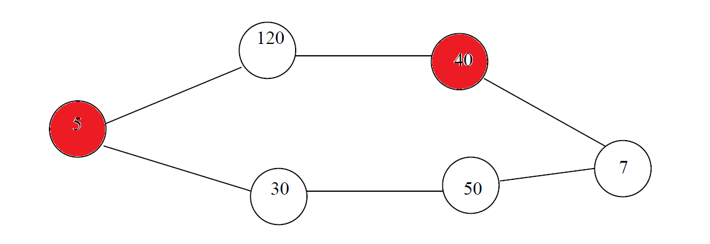
An example of a NOT allowed subset is shown below (two competing companies are in the subset).
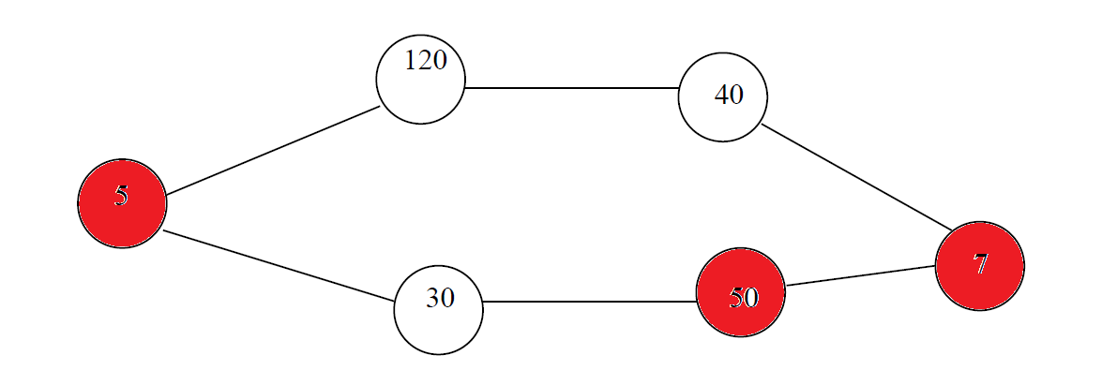
Let’s call the vertices $V_{1}$, $V_{2}$,…,$V_{n}$ of $G$ such that
- $V_{1}$ and $V_{2}$ have an edge in between
- $V_{2}$ and $V_{3}$ have an edge in between
- $…$
- $V_{n-1}$ and $V_{n}$ have an edge in between
- $V_{n}$ and $V_{1}$ have an edge in between
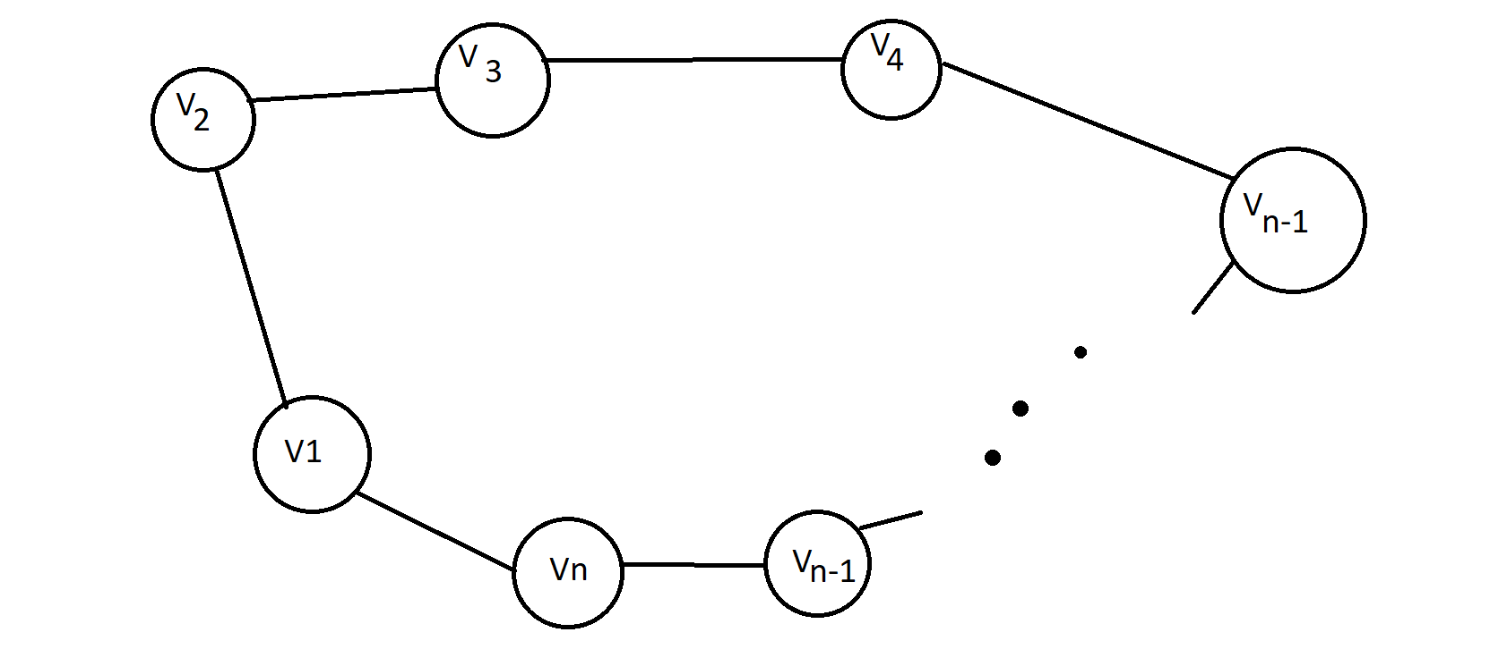
Before we proceed, let’s solve the special cases.
- We cannot have less than 3 companies, since it is assumed that each company competes “exactly” with two another companies (in problem description)
- If there are 3 companies, simply choose the company with the largest brand value.
Now, for general case $n>3$.
To simplify the problem, let’s cut the edge between $V_{1}$ and $V_{n}$ so the graph can be considered as flat array.
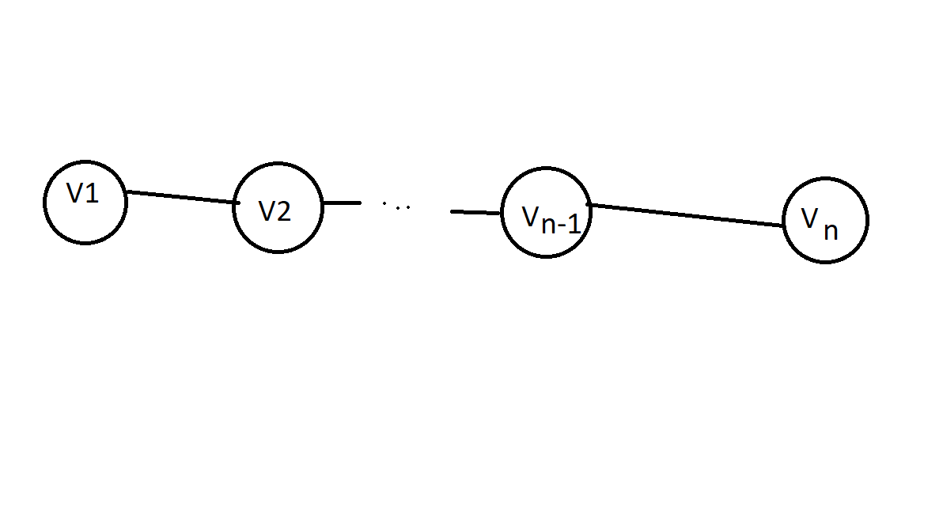
Setup an optimal function
$$\text{OPT}\left(i,V_{1} \text{picked}\text{ or not}\right)$$
This means the maximum total brand value after examining $V_{1},V_{2},…,V_{i}$ and under the assumption that $V_{1}$ is included in the maximum total brand value or not.
So,
$$\text{OPT}\left(1,\text{true}\right)=\text{value}\left(V_{1}\right)$$
$$\text{OPT}\left(1,\text{false}\right)=0$$
$$\text{OPT}\left(2,\text{true}\right)=\text{value}\left(V_{1}\right)$$
$$\text{OPT}\left(2,\text{false}\right)=\text{value}\left(V_{2}\right)$$
$$\text{OPT}\left(3,\text{true}\right)=\text{value}\left(V_{1}\right)+\text{value}\left(V_{3}\right)$$
$$\text{OPT}\left(3,\text{false}\right)=\max\left(\text{value}\left(V_{2}\right)\text{, }\text{value}\left(V_{3}\right)\right)$$

…
$$\text{OPT}\left(i,\text{true}\right)=\text{max}\left(\underset{\text{include} V_{i}}{\underbrace{\text{value}\left(V_{i}\right)+\text{OPT}\left(i-2,\text{true}\right)}},\underset{\text{don't }\text{include} V_{i}}{\underbrace{\text{OPT}(i-1,\text{true})}}\right)$$
$$\text{OPT}\left(i,\text{false}\right)=\text{max}\left(\underset{\text{include} V_{i}}{\underbrace{\text{value}\left(V_{i}\right)+\text{OPT}\left(i-2,\text{false}\right)}},\underset{\text{don't }\text{include} V_{i}}{\underbrace{\text{OPT}\left(i-1,\text{false}\right)}}\right)$$
…
$$\text{OPT}\left(n,\text{true}\right)=\underset{\text{don't }\text{include} V_{n}, \text{since} V_{1} \text{is included}}{\underbrace{\text{OPT}(n-1,\text{true})}}$$
$$\text{OPT}\left(n,\text{false}\right)=\text{max}\left(\underset{\text{include} V_{n}}{\underbrace{\text{value}\left(V_{n}\right)+\text{OPT}\left(n-2,\text{false}\right)}},\underset{\text{don't }\text{include} V_{n}}{\underbrace{\text{OPT}\left(n-1,\text{false}\right)}}\right)$$
With this formulation, we final answer we are looking for is then
$${\text{OPT}}_{\text{final}}=\max\left(\text{OPT}\left(n,\text{true}\right),\text{OPT}\left(n,\text{false}\right)\right)$$
The algorithm is correct by construction.
The time complexity is $O(n)$ as we are building two arrays, and each array’s last element only dependent on the previous one and the previous two elements, which we already have without the need of extra calculations.
The space complexity is also $O\left(n\right)$ since we need to store two arrays. However, if we observe the fact that only previous two elements are used, we can just use two variables and update them. This is an optimization to reduce the space complexity to $O\left(1\right)$; this optimization, however, discards history.
To find out exactly companies are chosen in the MPP, simplify add metadata to each $\text{OPT}\left(i,⋅\right)$ to record whether $V_{i}$ is included or not. We can then trace back from ${\text{OPT}}_{\text{final}}$ to output which companies are in MPP. However, this way, we prohibit the optimization to reduce the space complexity from $O\left(n\right)$ to $O\left(1\right)$.

